

Nomad Flight Performance Expansion

1 September 2019

Version 1.2

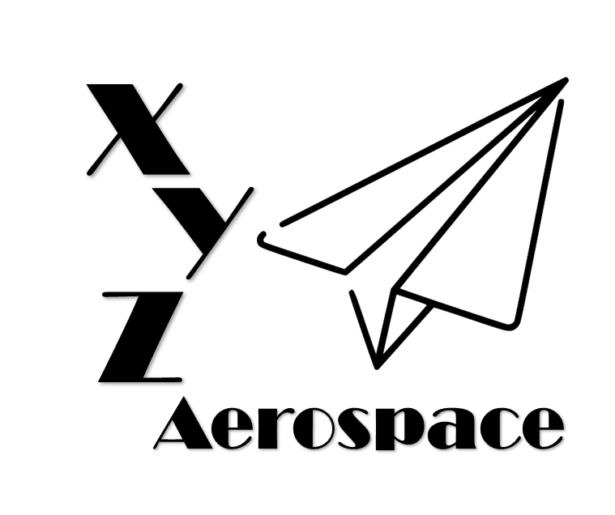

645 Colonel Glenn Blvd

Dayton, Ohio

DISCLAIMER: This document has been produced to support training and experimentation ONLY. It does not represent any system, real or planned. No United States Government resources were used to produce this document.

**THIS PAGE IS INTENTIONALLY BLANK**

Contents

1. Introduction 5

2. Flight Performance 5

1. Maximum 5

3. Control Communications 5

**THIS PAGE IS INTENTIONALLY BLANK**

1. Introduction
2. Navigation
   1. Test 1
      1. Stationary Error

Fails

* + 1. Moving Error

Passes

* 1. Test 2
     1. Jam Resistance

Fails pointing accuracy, moving error.

* 1. Test 3
     1. Updated FCS Regression Testing

Passes, describe and summarize analysis

1. Control Link
   1. Test 3
      1. Link Flooding

Fails